# Prom02 – Appendices

Student Name: Yue Fung (Lewis)

Student Number : 199124958

Programme: MSc Data Science

# **Project Achievements, Challenges and Impacts**

## Achievements

After all, Ambros instructed me to prepare such research, and their main goal might be to develop an option which relied on professional services which could be less depend on machine learning result and build a data product. Hence, I have three critical points that I should communicate my success in this research to drive the new product – Machine Learning as SaaS instead of developing a professional service team.

|  |  |  |  |
| --- | --- | --- | --- |
| Achievement | Significance | Skills & Knowledge | Evidence |
| The result provided a great machine learning model for customer who needs to understand the pattern of opening a new restaurant. | According to the practice of this research, it may become F&B industry knowledge for restaurants to source a new location. | -F&B domain knowledge  -Excel, Python and Data cleaning  -Data analysis  -ML algorithm selection  -Problem solving skills | Brown and Mitchell, 1993  Ayyadevara, 2018  Kim and Gu, 2006  Refer to Chapter 4 |
| Better prediction of restaurant sales and customer service based upon earlier customer behaviour data. | For restaurant operators who need to plan forward for future expansion or cost savings, restaurant sales forecasts are a critical consideration factor. | -Feature engineering  -ML algorithm selection and cross validation  -Data Modelling  -Time management | Tanizaki et al., 2019  Lasek et al., 2016a  Refer to Chapter 3 |
| Ambros will offer restaurant owner truly personalized services recommendations | It enables Ambros to be more competitive in the industry by adding additional value to their existing SaaS product. | -Algorithms & Optimization  -Python programming  -Data structures  -Problem solving skills | Mathur, 2018,  Lian et al., 2017b, Lian et al., 2017a,  Refer to Chapter 2 and 3 |

## Challenges

|  |  |  |  |
| --- | --- | --- | --- |
| Challenge | Explanation | Approach & Solutions | Evidence |
| Data Collection | Find data, consolidate those data from Ambros, Government and Property agency from web scraping spent a lot of time which over 50%-60% of the research. Once the data is collected, validation of those data quantity is sufficient also. | -Data cleaning with excel and Python tools  -Dimensionality reduction, remove some variable which may not affect the result.  -Instance selection, it aims to reduce a dataset’s height. Diverse and include random selection, genetic algorithm based selection, progressive sampling, using domain knowledge and cluster sampling. | L’heureux et al., 2017  Refer to Chapter 2.2 |
| Selection of Machine Learning Models | Model selection is the process of evaluating or assessing candidate models in order to select the best one. Whereas, once a model has been selected, it can be evaluated in order to communicate how well it is expected to perform in general. | -A model that satisfies the needs and constraints of Ambros expectation.  -Split the data into training, validation, and test sets, then fit candidate models on the training set, evaluate and select them on the validation set, and report the performance of the final model on the test set. | Kim and Gu, 2006  Refer to Chapter 2.3 |
| Python programming and debugging | When fine tuning the data csv during the training phase. The python code is essentially changing or evolving as the model trains. A lot of parameters or wights in the model are changing in every step during training. It shops changing once training is complete, at which pint what bugs I didn’t catch during the training are part of the model. | I must be able to capture model and optimizer specific information during training. Monitor and react to changes in the capture data with assertion rules that get triggered when a condition is met, eg. over fitting. | Mathur, 2018  Refer to Chapter 3 |

## The Project/Research - Advancing Knowledge and Skills

The impact of this research on me are that best practice flow is used to calculate the restaurant status and predict the sales forecast of a restaurant using machine learning regression models. These studies can also include a literature review and demonstrate the whole technology for achieving the best results for certain industries, eg. F&B. This journey begins only and every year the field of machine training grows fast. I should stay on top of all related news and learn how to produce the best machine learning algorithms in varies industries.

# **Project Management**

## Forecast and Actual delivery – Diagram & Explanation

**The updated project schedule and deliverable – Final Gantt Chart version 2.0**

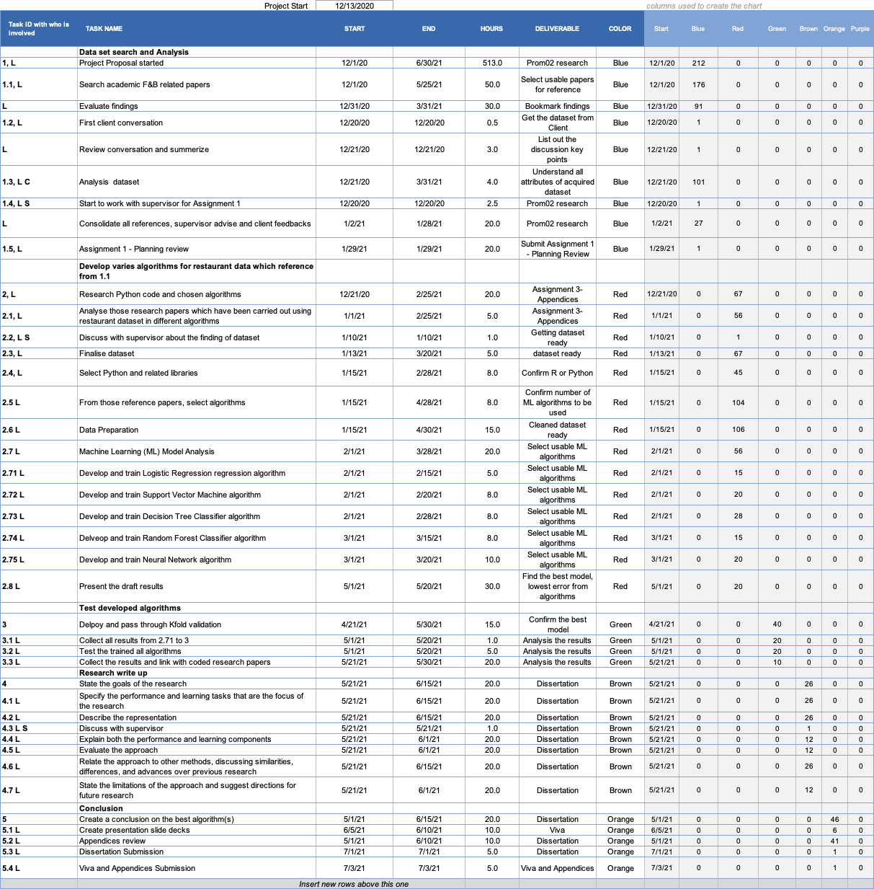

**

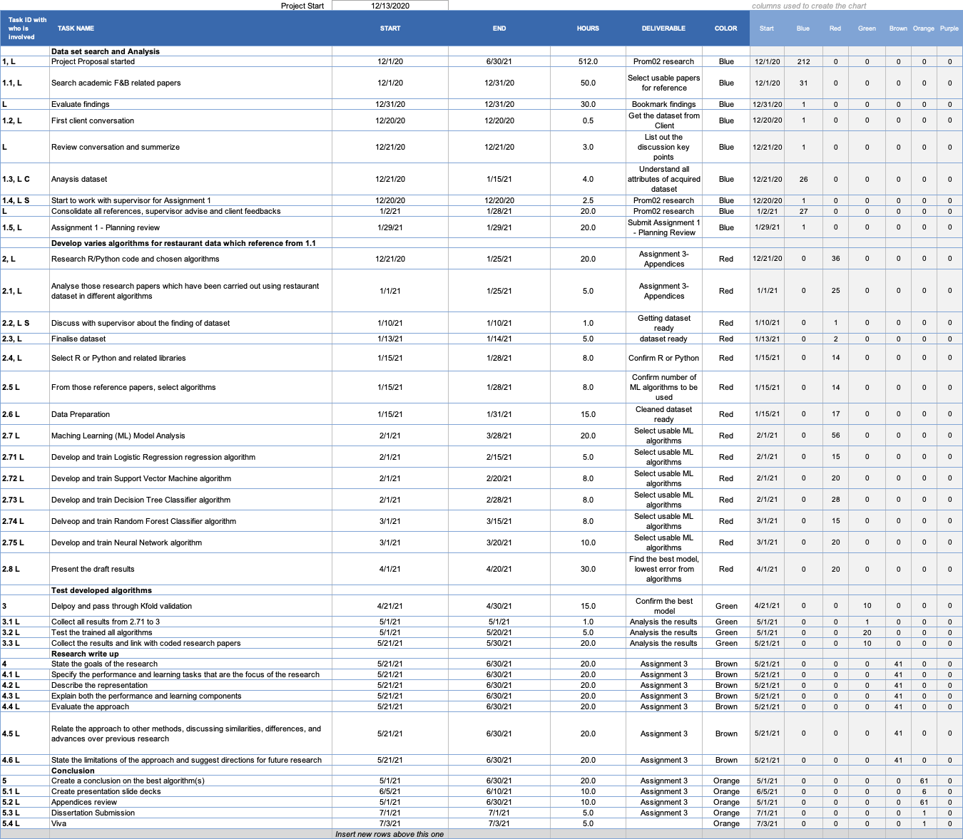

According to above Gantt chart v2 vs v1, there are some major different from original planning to the actual work: -

1. The real time spent searching for a reference academic article was far longer than anticipated.

2. Data reduction and data transformation during data cleansing consume more than 60% of the total planning time.

3. Deployment of the test and training sets from Python also necessitates a significant amount of adjustment between dataset and Python code modifications. It also took significantly longer than intended.

## Project Management Methods, Techniques and Tools

|  |  |  |  |
| --- | --- | --- | --- |
| Method / Technique / Tool | Use & Rationale | Appropriateness | Evidence |
| Agile project method, MS excel or Trello is the project management tool that helps to accomplish the research | Machine learning project could use an agile approach, it is useful to take a step back and define the key concepts that should drive a lean agile machine learning project. | 1.Roles – research owner, process expert, data owner etc..  2.Eventsv - daily or weekly reviews  3.Process to create and prioritize items – items/tasks are created, prioritized and viewed on task board in Trello. | Larson and Chang, 2016 |
| Data driven scrum (DDS), tool is scrum Kanban, DDS guide | DDS helps to ensure that me and the Ambros can achieve some key achievements | 1.Functional iterations 2. Flexible task estimation. 3. Iteration independent meeting 4.Collective analysis | Wei and Rana, 2019 |

# **Evidence**

|  |  |  |
| --- | --- | --- |
| Section 1 Evidence | Section 2 Evidence | Section 3 Evidence |
| Brown and Mitchell, 1993  Ayyadevara, 2018  Kim and Gu, 2006 | L’heureux et al., 2017 | Larson and Chang, 2016 |
| Tanizaki et al., 2019  Lasek et al., 2016a | Kim and Gu, 2006 | Wei and Rana, 2019 |
| Mathur, 2018,  Lian et al., 2017b, Lian et al., 2017a, | Mathur, 2018 |  |

Presentation Slides:-

<https://github.com/nunufung/PROM02/blob/main/Prom02%20ppt%20v1.46.pdf>

Python code in github

<https://github.com/nunufung/PROM02/blob/main/Restaurant_Sales_and_Status_Predictions_v5.ipynb>

Dataset CSV in github

<https://github.com/nunufung/PROM02/blob/main/dataset%20v7_57k%20another%20pattern%203.csv>

Books and reference in github

<https://github.com/nunufung/PROM02>

# **References**

(Van Der Malsburg, 1986, Brown and Mitchell, 1993, Wolpert, 1996, Pinkus, 1999, Platt, 2001, Bilenko and Mooney, 2003, Kim and Gu, 2006, Cutler et al., 2007, Goldfarb and Tucker, 2011, Schrouff et al., 2013, Larson and Chang, 2016, Lasek et al., 2016a, Lasek et al., 2016b, Nam et al., 2016, Steele et al., 2016, Kirk, 2017, L’heureux et al., 2017, Lian et al., 2017b, Lian et al., 2017a, Ayyadevara, 2018, Holmberg and Halldén, 2018, Khan and Roy, 2018, Mathur, 2018, Te et al., 2018, Adolfsson and Andersson, 2019, Tanizaki et al., 2019, Wei and Rana, 2019, Bruce et al., 2020, Dulhare et al., 2020, Gressling, 2020, Shrove and Jovanov, 2020, Varatharajan et al., 2020)

ADOLFSSON, R. & ANDERSSON, E. 2019. Improving sales forecast accuracy for restaurants.

AYYADEVARA, V. K. 2018. Pro machine learning algorithms. *Apress: Berkeley, CA, USA*.

BILENKO, M. & MOONEY, R. J. Adaptive duplicate detection using learnable string similarity measures. Proceedings of the ninth ACM SIGKDD international conference on Knowledge discovery and data mining, 2003. 39-48.

BROWN, K. A. & MITCHELL, T. R. 1993. Organizational obstacles: Links with financial performance, customer satisfaction, and job satisfaction in a service environment. *Human relations,* 46**,** 725-757.

BRUCE, P., BRUCE, A. & GEDECK, P. 2020. *Practical Statistics for Data Scientists: 50+ Essential Concepts Using R and Python*, O'Reilly Media.

CUTLER, D. R., EDWARDS JR, T. C., BEARD, K. H., CUTLER, A., HESS, K. T., GIBSON, J. & LAWLER, J. J. 2007. Random forests for classification in ecology. *Ecology,* 88**,** 2783-2792.

DULHARE, U. N., AHMAD, K. & AHMAD, K. A. B. 2020. *Machine Learning and Big Data: Concepts, Algorithms, Tools and Applications*, John Wiley & Sons.

GOLDFARB, A. & TUCKER, C. E. 2011. Privacy regulation and online advertising. *Management science,* 57**,** 57-71.

GRESSLING, T. 2020. 36 Second generation: classification. *Data Science in Chemistry.* De Gruyter.

HOLMBERG, M. & HALLDÉN, P. 2018. Machine Learning for Restaurant Sales Forecast.

KHAN, P. M. & ROY, K. 2018. Current approaches for choosing feature selection and learning algorithms in quantitative structure–activity relationships (QSAR). *Expert opinion on drug discovery,* 13**,** 1075-1089.

KIM, H. & GU, Z. 2006. Predicting restaurant bankruptcy: A logit model in comparison with a discriminant model. *Journal of Hospitality & Tourism Research,* 30**,** 474-493.

KIRK, M. 2017. *Thoughtful machine learning with Python: a test-driven approach*, " O'Reilly Media, Inc.".

L’HEUREUX, A., GROLINGER, K., ELYAMANY, H. F. & CAPRETZ, M. A. 2017. Machine learning with big data: Challenges and approaches. *Ieee Access,* 5**,** 7776-7797.

LARSON, D. & CHANG, V. 2016. A review and future direction of agile, business intelligence, analytics and data science. *International Journal of Information Management,* 36**,** 700-710.

LASEK, A., CERCONE, N. & SAUNDERS, J. 2016a. Restaurant sales and customer demand forecasting: Literature survey and categorization of methods. *Smart City 360°***,** 479-491.

LASEK, A., CERCONE, N. & SAUNDERS, J. 2016b. Smart Restaurants: Survey on customer demand and sales forecasting. *Smart Cities and Homes***,** 361-386.

LIAN, J., ZHANG, F., XIE, X. & SUN, G. CCCFNet: a content-boosted collaborative filtering neural network for cross domain recommender systems. Proceedings of the 26th international conference on World Wide Web companion, 2017a. 817-818.

LIAN, J., ZHANG, F., XIE, X. & SUN, G. Restaurant survival analysis with heterogeneous information. Proceedings of the 26th International Conference on World Wide Web Companion, 2017b. 993-1002.

MATHUR, P. 2018. *Machine Learning Applications Using Python: Cases Studies from Healthcare, Retail, and Finance*, Apress.

NAM, H., BAEK, M. & HAN, B. 2016. Modeling and propagating cnns in a tree structure for visual tracking. *arXiv preprint arXiv:1608.07242*.

PINKUS, A. 1999. Approximation theory of the MLP model. *Acta Numerica 1999: Volume 8,* 8**,** 143-195.

PLATT, J. C. 2001. Methods and apparatus for building a support vector machine classifier. Google Patents.

SCHROUFF, J., ROSA, M. J., RONDINA, J. M., MARQUAND, A. F., CHU, C., ASHBURNER, J., PHILLIPS, C., RICHIARDI, J. & MOURÃO-MIRANDA, J. 2013. PRoNTo: pattern recognition for neuroimaging toolbox. *Neuroinformatics,* 11**,** 319-337.

SHROVE, M. T. & JOVANOV, E. 2020. Early Outcome Prediction of Software Projects using Software Defects and Machine Learning. *Journal of Software Engineering Practice,* 4**,** 1-12.

STEELE, B., CHANDLER, J. & REDDY, S. 2016. *Algorithms for data science*, Springer.

TANIZAKI, T., HOSHINO, T., SHIMMURA, T. & TAKENAKA, T. 2019. Demand forecasting in restaurants using machine learning and statistical analysis. *Procedia CIRP,* 79**,** 679-683.

TE, Y.-F., MULLER, D., WYDER, S. & PRAMONO, D. 2018. Predicting the Growth of Restaurants Using Web Data. *Economic and Social Development: Book of Proceedings***,** 237-256.

VAN DER MALSBURG, C. 1986. Frank rosenblatt: Principles of neurodynamics: Perceptrons and the theory of brain mechanisms. *Brain theory.* Springer.

VARATHARAJAN, M. N., GURUPRASAD, J. & MATHUMITHA, K. 2020. Restaurant Recommendation System Using Machine Learning. *International Educational Applied Research Journal,* 4**,** 1-4.

WEI, W. & RANA, M. E. 2019. Software Project Schedule Management Using Machine Learning & Data Mining. *International Journal of Scientific & Technology Research,* 8**,** 1385-1389.

WOLPERT, D. H. 1996. The lack of a priori distinctions between learning algorithms. *Neural computation,* 8**,** 1341-1390.